

Presented to Local Committee | October 2025
Lead SMT | Headteacher
Approved by Local Committee on: | October 2025
Review Cycle: | Annual
Review Date: | October 2026

Behaviour and Relationship Policy
Our Shared Vision

The aim of the policy is to create a secure, inclusive and happy school, where we are all nurtured, grow and flourish together through building strong relationships and a sense of belonging.
He will be like a tree planted by the streams of water, that produces its fruit in its season, whose leaf also does not wither. Whatever he does shall prosper. Psalm 1:3

We expect all members of our school to adhere to Surrey Hill's six core Christian values of Aspire, Love, Believe, Achieve, Hope and Respect. These lie at the heart of the high expectations we have for behaviour in our school. We recognise that behaviour is communication and use nurture principles alongside restorative practices. We believe the best way to ensure positive behaviour is to make learning in class engaging, creative and fulfilling. Pupils achieving positive outcomes will flourish and the outcome of this vision is children thrive socially and academically.

Aims
▪ create an environment which encourages and reinforces our Surrey Hills expectations
▪ model acceptable standards of behaviour at all times in the day and teach effective learning behaviours
▪ promote respect and tolerance of all, through the building strong relationships

The Restorative Approach, Ready to Learn.
Restorative practice involves helping children think through their behaviour, its consequences and what they can do to make it better. We are giving pupils the skills to understand that their behaviour is their responsibility, to self-reflect and make more informed empathetic choices in the future. A clear process of select questioning helps pupils identify when and how they need to regulate and restore relationships.

Roles and Responsibilities
Reinforcing, expecting and modelling positive behaviour is a shared responsibility. Adults provide effective classroom culture and develop positive relationships with and between pupils by creating a culture of trust in their classroom.
All adults encountered by the children at school have an important role: model Surrey Hills expectations, use positive language and a restorative approach, recognise and respond consistently, calmly and empathetically to behaviours, follow our behaviour steps to help pupils to: understand the impact of their actions, take responsibility and understand how to repair a situation or conflict. At lunchtimes, mid-day supervisors support positive play in the lunchtime areas. The classroom is used in a variety of ways as a tool to promote positive behaviour and exemplify where behaviour has been positive. Senior leaders meet weekly to review behaviours. Communication with parents and carers is also key.

Behaviour-related praise system
Our emphasis on behaviour –related praise including reward systems is part of our classroom management strategy.
We believe that rewards have a motivational role, helping children to see that following expectations are valued. Rewards used include a range of both intrinsic and extrinsic strategies, whole school and individual. Celebration of children’s work and effort is used to reward.
.
Consequences

Our behaviour for learning is clearly set out with visuals in each classroom of our Surrey Hills expectations. If these are not followed, a behaviour flowchart is followed consistently to address incidents so that children consider their actions and can restore relationships in line with the Paul Dix approach. Consequences range from a conversation to prohibit or discourage behaviour and to restore relationships, the withdrawal of privileges, a meaningful letter and, in exceptional circumstances, following persistent incidents, suspension. This is further explained in our Suspension and Exclusion Policy.

In the case of children who leave the school site unexpectedly during the school day, it is the policy to call the Police and contact the parents. A member of the senior staff may follow if they deem it safe (for the child) to do so.

Rarely, when needed, de-escalation and Team Teach strategies are used to ensure the wellbeing of all children.

Discriminatory Incidents
The school follows The Good Shepherd Trust guidelines on reporting discriminatory incidents. Any behaviour towards another person(s) considered to be discriminatory in nature by any person(s) will be recorded using The Good Shepherd Trust Reporting guidelines.

Support
For pupils who are struggling with behaviour management, Surrey Hills will provide targeted pastoral support, intervention or mentoring by adults or peers (i.e. ELSA; positive play, circle of friends, peer buddies/mentors).

Surrey Hills Expectations
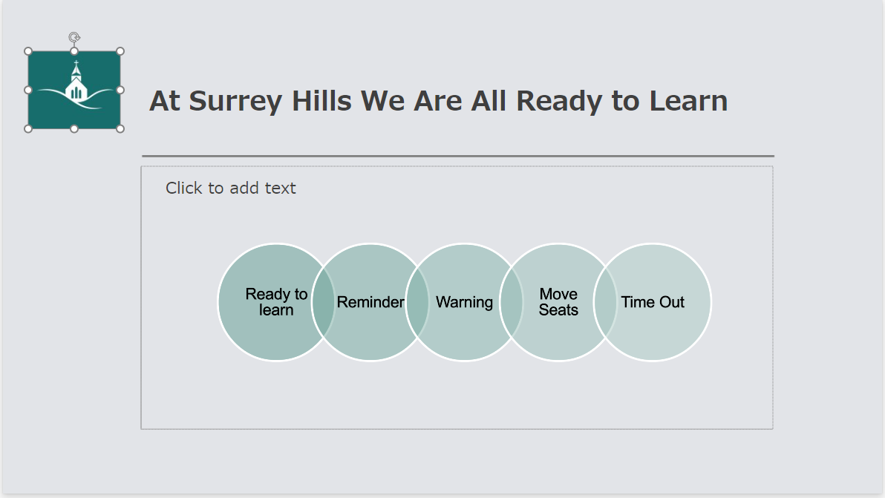
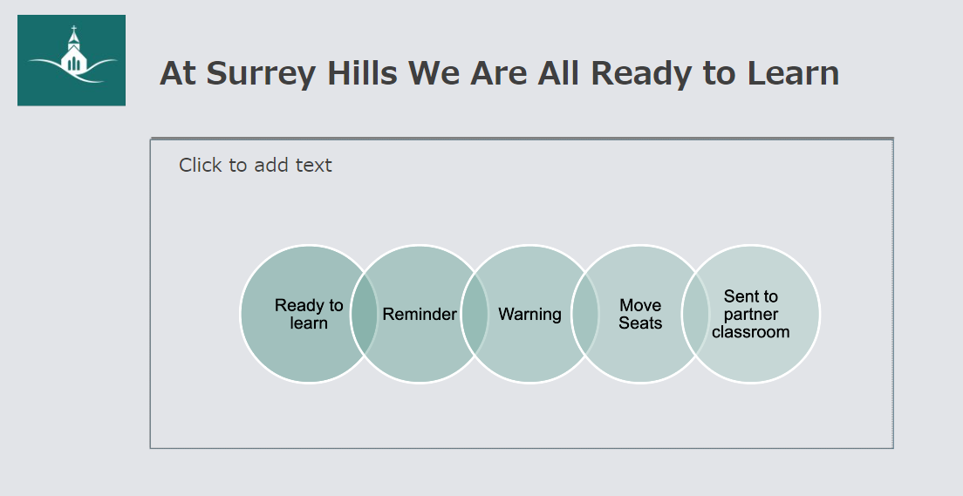

Our Surrey Hills Expectations

